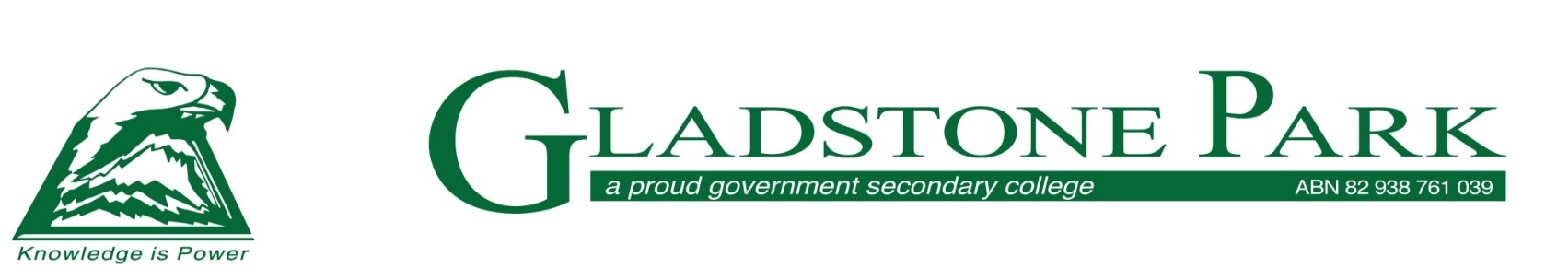

**Italian Content and Language Integrated Learning (CLIL)**

**Information for Parents and Carers**

Thank you for your interest in applying for the Italian CLIL Program at Gladstone Park Secondary for 2024. The school has worked with Edutest to design a series of tests to identify students who are suitable for the programme.

* Only students who are currently in Grade 6 may apply.
* You must nominate Gladstone Park Secondary College as your **first preference school** when completing the state-wide “Application for Year 7 Placement 2023 form” to be eligible for testing.
* If you are unable to attend on the day **we can make provisions** for your child to sit the GPSC test at a later date (usually after school at GPSC in the week after the Saturday test) but **you must** let Edutest aware of this requirement **before the testing date**.

**Selection procedures for the 2024 Year 7 intake:**

1. Information obtained from applicants through the Edutest website – photo identification, NAPLAN, school reports, parents/carers, and student statements
2. Tests administered on **Saturday 19th August at 9:30am** at Gladstone Park Secondary College.
3. First Round offers will be made by phone and confirmed by mail

You must apply on-line for the testing by using the following link.

<https://aus.edutest.com.au/D/?t=8bu557l9>

We would appreciate all applications be made to Edutest by **Monday 22nd May**. to facilitate reconciliation with “Application for Year 7 Placement 2024” forms. The final closing date for applications is Friday 4th August.

Testing of your child will take place at Gladstone Park Secondary College on **Saturday 19th August at 9:30am**.

Children and parents should report at **9:00am to the Senior School Building on the North side of the school**.

Parents should be prepared to collect the children at approximately 12.30 pm.

**What to bring:**

* A snack and drink for the short recess between the different tests.
* Two blue or black pens, two 2HB pencils, a pencil sharpener and an eraser.
* Mobile phones are not permitted. Parents are not permitted in the testing room.

**Italian CLIL Information session:**

More information will be provided at our **Information Evening on Wednesday 3rd May, which will start at 6:00pm** in the Performing Arts Centre; and through our open day on **Wednesday 10th May**.

If you have any queries, please contact the school during school hours on 9933 0500 or email the Italian and Immersion Coordinator, Mr Andrea Caponeri, at [andrea.caponeri@education.vic.gov.au](mailto:andrea.caponeri@education.vic.gov.au)

Jody Scott

Principal – Junior School